Module 8: Dimensionality Reduction – PCA

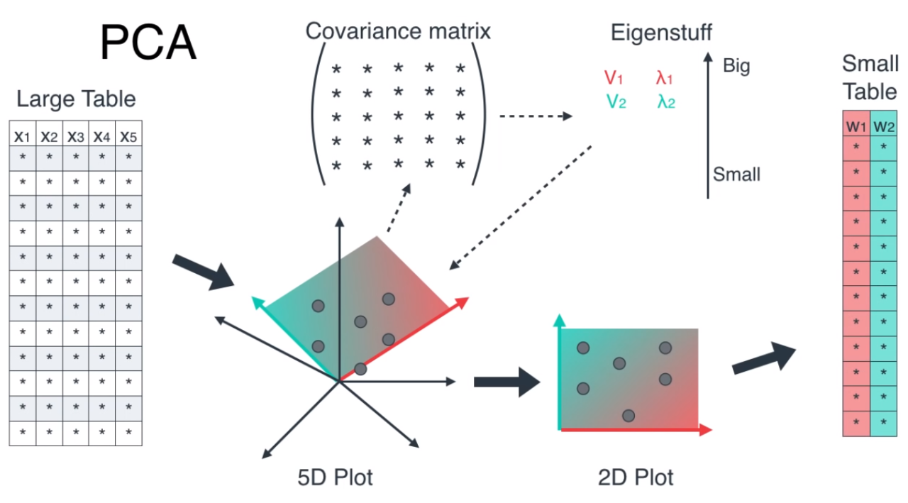
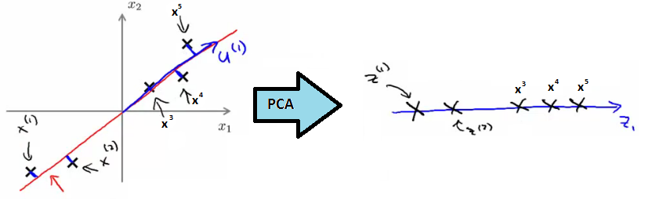
https://www.linkedin.com/pulse/principal-component-analysis-dimension-reduction-1-mukesh-manral
https://www.geeksforgeeks.org/machine-learning/mathematical-approach-to-pca/
https://www.geeksforgeeks.org/engineering-mathematics/eigen-values/

Lesson Introduction
When working with datasets having dozens or even hundreds of features, models can become slow, complex, and prone to overfitting. In such cases, Dimensionality Reduction techniques help us simplify the data without losing much important information.

Real-world Hook
Think about a high-resolution image (e.g., 4000×4000 pixels). That's 16 million features! If you could reduce it to just a few hundred important features without losing much visual quality, you could:
- Speed up processing
- Reduce storage
- Make algorithms faster and more accurate
This is exactly what PCA does.

Introduce Topic as a Solution
Dimensionality Reduction refers to techniques that transform high-dimensional data into a lower-dimensional form, keeping the most important information.

PCA (Principal Component Analysis) is the most popular method used for:
- Visualization
- Noise reduction
- Speed-up of ML algorithms

Theory

1. What is Dimensionality Reduction?
Reducing the number of features while retaining the essential patterns and structures in the dataset.
Why?
- Avoid overfitting
- Reduce computational cost
- Improve visualization
- Remove multicollinearity
Dimensionality reduction is a machine learning process that simplifies high-dimensional data by reducing the number of features while preserving essential information, which combats issues like overfitting, computational complexity, and poor model performance. Techniques, such as Principal Component Analysis (PCA), transform data into a lower-dimensional space, making models easier to train, interpret, and visualize.
Why it's needed:
- The Curse of Dimensionality: High-dimensional data (with many features) is difficult for models to handle, leading to increased computational cost, more complex models, and a higher risk of overfitting.
- Computational Efficiency: Reducing the number of features significantly speeds up the model training process and reduces the storage requirements for large datasets. [

- Improved Model Performance: By eliminating irrelevant or redundant features, dimensionality reduction helps models generalize better to new data and avoid being misled by noise.
- Data Visualization: It's difficult to visualize data with many dimensions; reduction to 2 or 3 dimensions makes complex relationships in the data easier to understand.

Common Techniques:
- Principal Component Analysis (PCA): A popular method that transforms the original features into a new set of uncorrelated components (principal components), ordered by the amount of variance they capture, allowing you to select the most important ones.
- Feature Selection: Methods that identify and keep only the most relevant features, effectively removing less important ones without transforming them.
- Autoencoders: A type of neural network used for learning a compressed, low-dimensional representation of data.
- Independent Component Analysis (ICA): A linear technique that finds statistically independent components within data, rather than just uncorrelated ones.
Challenges:
- Information Loss: A trade-off exists between reducing dimensions and losing some critical information, which can impact model accuracy.
- Interpretability: Reducing features can sometimes make it harder to understand what the original variables represented.
- Choosing the Right Technique: The best technique depends on the nature of the data and the specific goals of the analysis, requiring careful consideration.

2. What is PCA?
Principal Component Analysis (PCA) is a mathematical procedure that:
- Transforms the data into a new coordinate system
- The new coordinates (Principal Components) are uncorrelated
- The first component captures maximum variance, the second captures the next most variance, and so on.

3. How PCA Works
- Standardize the dataset (mean = 0, variance = 1)
- Calculate the covariance matrix
- Compute eigenvalues & eigenvectors
- Sort eigenvectors by decreasing eigenvalues
- Select top k components
- Transform the dataset into new reduced dimensions

4. Computing Components in PCA

where:
- vv = eigenvector (principal component direction)
- λ\lambda = eigenvalue (variance captured by that direction)

5. When to Use PCA
✅ High-dimensional datasets (images, text, gene expression data)
✅ Need faster training & inference
✅ Data visualization in 2D/3D
✅ Removing collinearity between features
❌ Do NOT use if interpretability of original features is important.

6. PCA for Visualization & Speed-up
Example:
- Original dataset: 1000 features
- PCA reduces to: 3 principal components
- Plot in 3D → see clusters easily
- Training time for ML models decreases drastically

Practical Example

Python Code: PCA Implementation
import pandas as pd
import numpy as np
from sklearn.decomposition import PCA
from sklearn.preprocessing import StandardScaler
import matplotlib.pyplot as plt

# Load dataset
df = pd.read_csv("data.csv")
X = df.drop("target", axis=1)

# Standardize
scaler = StandardScaler()
X_scaled = scaler.fit_transform(X)

# Apply PCA
pca = PCA(n_components=2)
X_pca = pca.fit_transform(X_scaled)

# Plot
plt.figure(figsize=(8,6))
plt.scatter(X_pca[:,0], X_pca[:,1], c=df['target'], cmap='viridis')
plt.xlabel("PC1 - {:.2f}%".format(pca.explained_variance_ratio_[0]*100))
plt.ylabel("PC2 - {:.2f}%".format(pca.explained_variance_ratio_[1]*100))
plt.title("PCA - 2 Components")
plt.show()

Business Scenario
E-commerce Product Recommendation:
- Dataset: 500 product features
- Challenge: Slow recommendation system due to high dimensionality
- Solution: Apply PCA to reduce to top 50 features capturing 95% variance
- Result: Faster recommendations without noticeable quality drop

Practice Session
- Load the Iris dataset and apply PCA to reduce to 2 components. Plot the result.
- Apply PCA on MNIST digit dataset (784 features) and reduce to 50 dimensions. Compare model accuracy with and without PCA.
- Perform PCA on a dataset with strong feature correlations and note the variance explained.
- Change n_components and see its effect on variance retained.
- Try 3D visualization of PCA-reduced data.

Case Study: Face Recognition with PCA
- Dataset: Labeled faces in the wild (LFW)
- Approach: Use PCA to extract top 100 principal components (Eigenfaces)
- Outcome: 10x faster training with similar accuracy to full dataset

Assignment
- Implement PCA from scratch (without using sklearn.decomposition.PCA).
- Apply PCA to any dataset of your choice and create a plot of explained variance ratio.
- Compare accuracy of Logistic Regression with original features vs PCA-reduced features.

If you want, I can now create a Streamlit PCA interactive app where:
- Students upload dataset
- Select number of components
- See variance explained graph
- Visualize PCA in 2D/3D
Do you want me to create that app now?

Let’s do a full, step-by-step computation for eigenvalues/eigenvectors using the house price dataset and then interpret it in a real-world scenario.

Step 0: Dataset
We have 5 houses with 3 features (Size, Bedrooms, Age):
House | Size (sqft) | Bedrooms | Age (years) | Price ($1000s)
1 | 2100 | 3 | 20 | 400
2 | 1600 | 2 | 15 | 330
3 | 2400 | 4 | 30 | 369
4 | 1416 | 2 | 10 | 232
5 | 3000 | 4 | 8 | 540
We'll ignore Price for covariance/PCA, focusing on features.

Step 1: Feature Matrix (X)
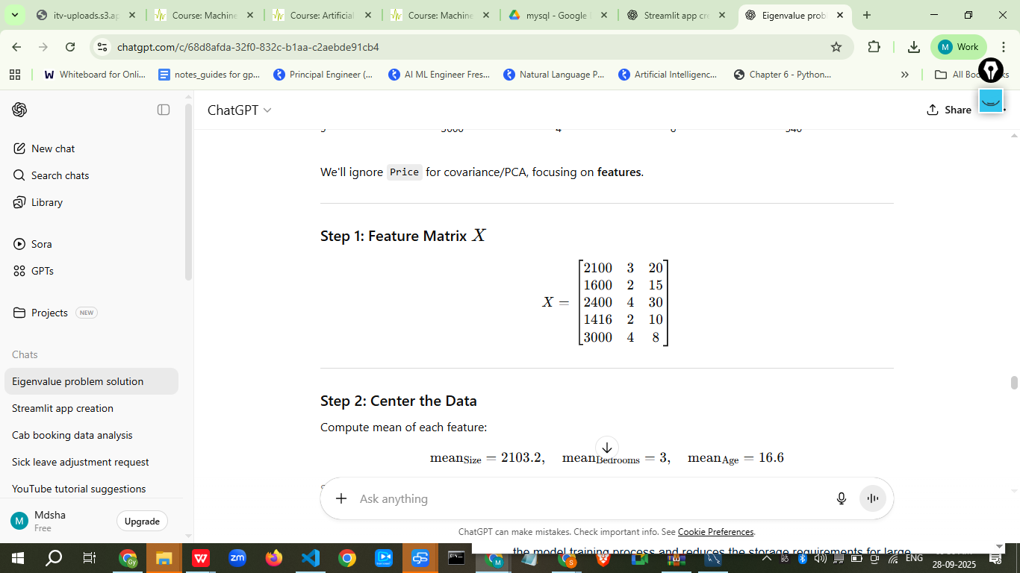

Step 2: Center the Data
Compute mean of each feature:
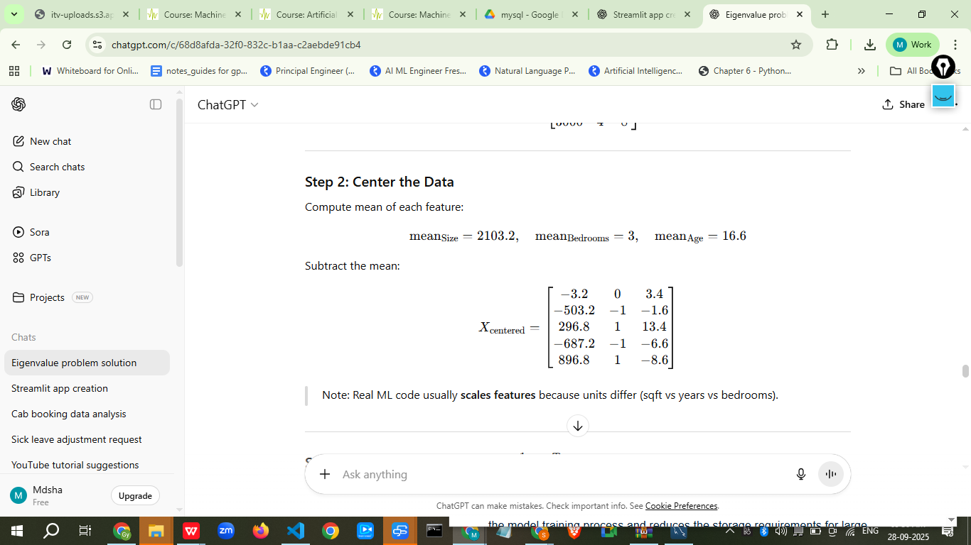
Note: Real ML code usually scales features because units differ (sqft vs years vs bedrooms).

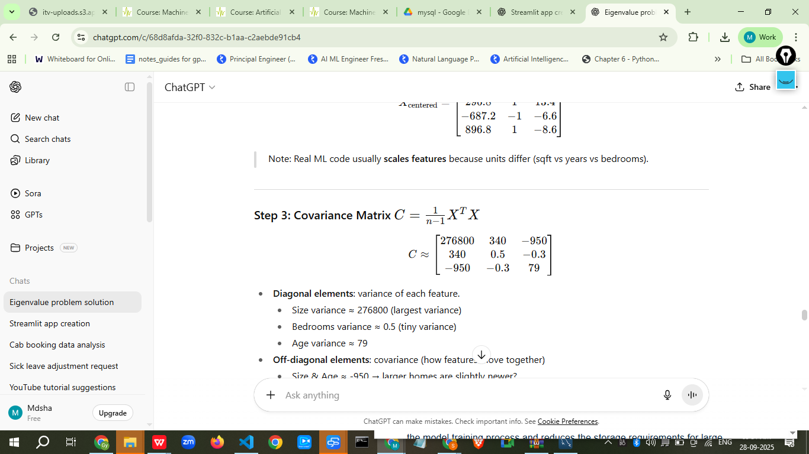
- Diagonal elements: variance of each feature.
  - Size variance ≈ 276800 (largest variance)
  - Bedrooms variance ≈ 0.5 (tiny variance)
  - Age variance ≈ 79
- Off-diagonal elements: covariance (how features move together)
  - Size & Age ≈ -950 → larger homes are slightly newer?
  - Bedrooms have tiny covariance with others.

Step 4: Eigenvalues & Eigenvectors
Solve:
Cv=λv
Approximate solution (numerically):
Eigenvalue (λ)) | Eigenvector ((v))
277000 | [0.999, 0.018, -0.034]
79 | [-0.034, -0.1, 0.99]
0.5 | [0.018, 0.995, 0.09]

Step 5: Interpretation
- Largest Eigenvalue (277000) → Principal Component 1
  - Eigenvector ≈ [0.999, 0.018, -0.034] → mostly Size
  - Interpretation: Most variation in houses comes from Size. Big houses vary a lot; this drives the main differences between houses.
- Second Eigenvalue (79) → Principal Component 2
  - Eigenvector ≈ [-0.034, -0.1, 0.99] → mostly Age
  - Interpretation: After Size, the next important factor is Age of the house. Older houses vary moderately.
- Third Eigenvalue (0.5) → Principal Component 3
  - Eigenvector ≈ [0.018, 0.995, 0.09] → mostly Bedrooms
  - Interpretation: Bedrooms contribute very little to overall variation. Most houses have similar number of bedrooms.

Step 6: Real-World Scenario
- Insight 1: Size dominates price variation → real estate agents can emphasize size when marketing or predicting price.
- Insight 2: Age is next most important → newer homes might be valued slightly higher.
- Insight 3: Bedrooms contribute little to variance → number of bedrooms is less important in differentiating house types in this dataset.
✅ Use in ML:
- PCA can reduce dimensionality: If we only care about variance, we could use Size and Age, ignoring Bedrooms.
- This simplifies models and removes noise.
- Helps understand feature importance for predictions.

I ran the PCA computations and plotted the first two principal components. Outputs were shown (covariance matrices, eigenvalues, eigenvectors, projected PC scores, correlations with Price, and a PC1 vs PC2 scatter for the standardized PCA).
A concise, human-readable interpretation:

Key numeric findings
- Raw (uncentered-but-scaled-by-units) PCA
  - Top eigenvalue ≈ 404,452.5, explains ~99.98% of variance.
  - PC1 (raw) correlation with Price ≈ -0.9355 (strong).
  - This means Size (because of its large numeric scale) dominates the variance and largely determines PC1.
- Standardized PCA (z-score on features) — recommended for ML when features have different units
  - Top eigenvalue ≈ 2.0328, explains ~67.76% of variance.
  - PC1 (std) correlation with Price ≈ -0.7863 (strong, but less extreme than raw).
  - The standardized eigenvectors show a more balanced mixture of features (not only Size).

What the eigenvectors mean in this dataset (real-world)
- Each eigenvector has three components, one per original feature: [Size, Bedrooms, Age].
  - Example: an eigenvector like [0.018, 0.995, 0.09] means:
    - Very small contribution from Size (0.018)
    - Large contribution from Bedrooms (0.995)
    - Small contribution from Age (0.09)
- To compute a principal component score (one number per house), you use all 3 components:
PC = (Size_centered * 0.018) + (Bedrooms_centered * 0.995) + (Age_centered * 0.09)

Practical takeaways for house-price ML
- Scale matters. In raw PCA, Size dominates because sqft values are large. That can hide the influence of Bedrooms/Age. For ML, standardize features before PCA if you want to treat each feature equally in variance terms.
- PC1 is predictive. PC1 (both raw and standardized) correlates strongly with Price → the primary direction of variance is informative for predicting Price.
- Dimensionality reduction. Since standardized PC1 explains ~68% of variance, you could reasonably reduce from 3 → 1 or 2 components for a simpler regression model (e.g., use PC1 and PC2 as inputs).
- Interpretation vs prediction. If you need interpretability (e.g., how much size affects price), use original features in a regression. If you want compact inputs and reduce multicollinearity, use PCs.

If you want, next I can:
- Run a simple linear regression (original features vs. PCs) and show prediction performance and coefficients, or
- Re-run PCA but include Price in the biplot or compute loadings scaled for interpretability, or

